Mo’s Algorithm

- Introduction
Being able to query a range of data is one of the most basic and useful tools in programming. Many problems require looking at a subset of data, not the whole dataset. For example, we may want to know the sum of a range, the number of distinct values in a range, or how often a certain value appears between two indices.
The naïve approach to query a range is to loop through the entire range to answer the query. This means the naïve approach has a runtime of O(Q*n) where n is length of range and Q is number of queries. This solution is too slow for very large inputs.
There are several algorithms and implementations that reduce the time complexity of range querying. Prefix Sums can answer range queries in O(1), but they are limited to work only for operations that can be subtracted. Fenwick Trees and Segment Trees handle associative operations on a range in O(log n) time. Sometimes we must use a more complex operation to answer the range query such as how many values appear at least K times in a range. To answer this, Fenwick Trees and Segment Trees are not the best solution because it is less efficient to answer that by merging smaller segments.
Mo’s Algorithm is an approach to range querying which excels Prefix Sum, Fenwick Trees, and Segment Trees in solving range queries with complex operations. Mo’s algorithm is a special application of sqrt-decomposition which divides the whole data into blocks of size sqrt(n). Mo’s algorithm is offline and therefore can select in what order queries are solved to allow maintain a current range and update the answer by simply adding and removing individual elements. Mo’s Algorithm is not the best in every case of range querying, but it is especially helpful for complex operations such as finding number of distinct elements in a range.

- Overall Intuitive Approach
Mo’s Algorithm for an array of length n takes a list of queries Q and orders their execution to most benefit from overlapping values in the queries. The array is divided into blocks of size sqrt(n). Each query [L, R] is sorted into a block based on its left index L. Queries are sorted first by lowest block and then by lowest right index R. Since our queries are ordered as we proceed from one query to another we can reuse the overlapping values and only add the additional values and remove the obsolete. We define the current range [curL, curR]. As we solve each query we increment curL and curR. When curL is incremented, the index that left the range (old curL) is removed. When curR is incremented, the index that join the range (new curR) is added. This means we do not have to recalculate the entire range, we can reuse from the past query and only update based on the differences in the ranges.

- Implementation
The implementation has two main parts:
- Ordering the queries
- Executing queries
First, for ordering queries, a query can be defined as:
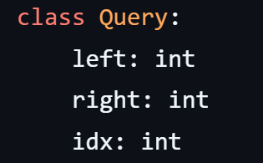
The index idx is necessary to place back the queries in the original order after sorting them.
The block size can be defined as:
The queries are then sorted:
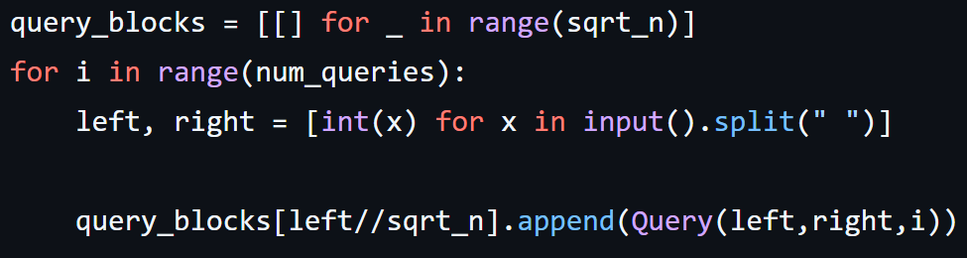
The queries are first added to buckets based on the block of the left index, and then sorted per bucket according to lowest right index.

Having ordered the queries, we come to the second part of the implementation, executing the queries:
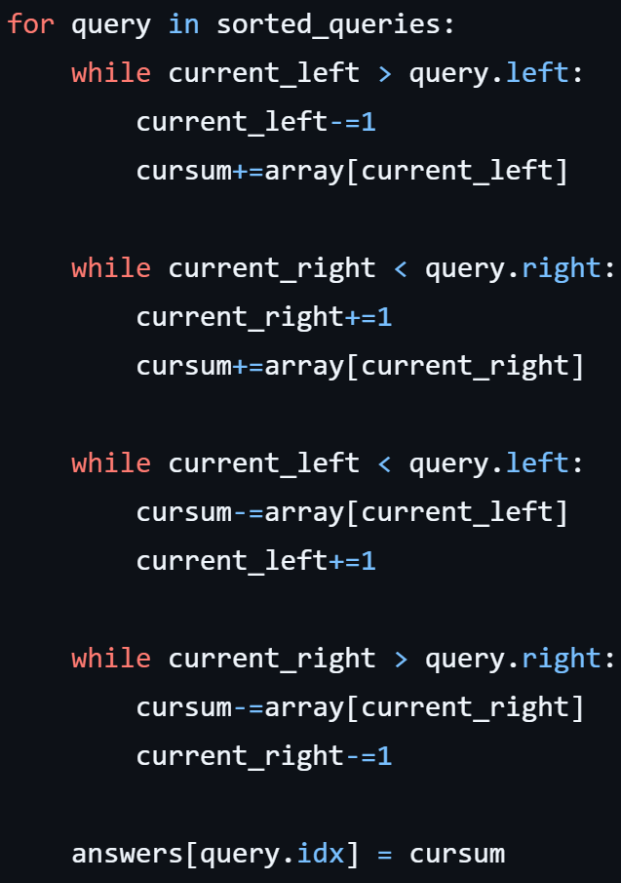
These four while loops adjust the current range and handle adding and removing elements. This implementation solves for the sum of a range. Other operations than sum can easily be substituted in each of these while loops.
The total runtime of Mo’s Algorithm is O((N + Q) · √N). This is based on the dominant term which is the range pointer movement. Updating curL is O(Q · √N) and updating curR is O(N · √N) and so the total work is O((N + Q) · √N)

- Summary of Programming Challenge
: Summarize the programming challange that you developed. We are particularly interested in a high-level description of what the learning objectives of your programming assignment are, and why you think your assignment achieves them. You should also focus on the key twist / idea, that goes beyond the basic topic, that is required to complete your assignment. Remember that finding a good level of additional challenge is important. Problems that go far beyond what can reasonably be expected from an average upperclass undergraduate student will incur grade penalties.
The programming challenge we developed asks students to analyze network request. Each request is represented by ID of the computer accessing the server. The student must provide functionality to answer two types of range queries. First, given a range [L, R] and a specific ID, return the frequency of that ID over the range, or the amount of times that ID shows up in the range. Second, given a range [L, R], return the number of unique IDs that appear at least K times over the range.
Our twist is that this programming challenge does not merely ask for a basic range query. We ask students to calculate two different complex operations on the moving range. Students will see that they must use Mo’s Algorithm to most efficiently solve this range query problem. Further, students will see the power of Mo’s Algorithm in an implementation that does not simply perform one simply range operation.

- Key Ideas for Solving Programming Challenge
Students will need to process all queries offline and sort them by block of left index and then by right index. This is a standard Mo’s Algorithm implementation. The more difficult part is working with range updates. For the first query the student will map IDs to its frequency in current range. For the second query students will keep track of how many IDs are currently at or above frequency K. Students can simply track when the frequency changes from K-1 to K and increase or decrease the count appropriately.
This is an interesting programming challenge that will thoroughly teach students that inner workings of Mo’s Algorithm. The Mo’s implementation here is quite standard, but significant understanding will be necessary to design the range updates.
- Conclusion
Mo’s Algorithm is an offline range querying solution that is helpful when queries are too complex to answer with Prefix Sum, Fenwick Tress, or Segment Trees. By sorting queries, Mo’s Algorithm can reuse much information between queries so that only certain values will need to be added or removed. This is a key efficiency of Mo’s Algorithm which saved by not recomputing values across queries.
The programming challenge shows a plausible application of Mo’s Algorithm to a situation where range queries are complex, specifically in a real example of network request analysis. It asks students to answer what the frequency of a value is over a range as well as the number of unique elements over a threshold. This is an opportunity to understand how Mo’s Algorithm sorts queries and also uses efficient add and remove operations.
To conclude, this project shows that Mo’s Algorithm is a useful tool to remember and implement when solving various problems which require the use of complex range queries.

